CSIT314 Software Development Methodologies - Group Project

Sprint 3 - US40: Platform manager log out
Interior Design Platform - Platform Manager
All diagrams were drawn in draw.io. Open "US40 Platform manager log out.drawio" in this folder to edit them - each diagram is its own page in that file. The exported images are in the "diagrams" folder.

Assumptions
- The system is the Interior Design Platform from the project specification. Sprint 3 adds the Platform Manager's stories (log out and IDP categories, US40 - US45) and the Interior Designer's first IDP story (add a current IDP, US20).
- We follow B-C-E: the actor only talks to the boundary (page), the boundary only talks to the controller, and the controller works with the entity classes. There is one controller per use case.
- Every Platform Manager page has a "Log out" button in the header (the dashboard and the IDP category pages). It sends a POST to /manager/logout. Opening /manager/logout with GET is not allowed and doesn't log anyone out.
- PlatformManagerLogoutController reuses the US2 LogoutController.logout(), then clears anything left in the session - the same way US19 does it for designers.
- No entity class is needed. Logging out only ends the browser session - it doesn't change the user account or any IDP category.
- After logging out the manager goes to the manager login page with "You have logged out successfully". If the session had already ended, the message is "Your session has already ended". The message is shown once only.
- A manager can always log out, even if their account or profile was suspended after they logged in.
- Logging out only ends the session in this browser, not on other devices.
- The User Admin's log out (US2, /logout) and the designer's log out (US19, /designer/logout) are not changed.

1. User story
Story ID | US40
User story | As a platform manager, I want to log out so that other people cannot use my account.
Actor | Platform Manager
Priority | High
Story points (estimate) | 1
Acceptance criteria | 1. Every Platform Manager page has a "Log out" button in the header.  2. Given I am logged in and click "Log out", then my session ends, I go to the manager login page and see "You have logged out successfully".  3. Given my session has already ended, when I log out, then I see "Your session has already ended".  4. After logging out, opening the manager dashboard or any IDP category page sends me to the manager login page.  5. Logging out doesn't change my account, and I can log in again.
Tasks | T40.1 Write the use case description and draw the use case diagram  T40.2 Draw the B-C-E class diagram and the sequence diagram  T40.3 Draw the wireframes for the log out button, logged out, session already ended and a blocked page  T40.4 Write the unit tests first (TDD) for PlatformManagerLogoutController and the log out page  T40.5 Code PlatformManagerLogoutController, reusing the US2 LogoutController  T40.6 Code PlatformManagerLogoutPage and add the "Log out" button to the manager header (platformManagerBase.html and the dashboard)  T40.7 Run the test cases, fix bugs and push to the repo so the CI pipeline runs the unit tests

2. Use case diagram
The user story becomes one use case, UC40 Platform manager log out. The Platform Manager is the only actor.
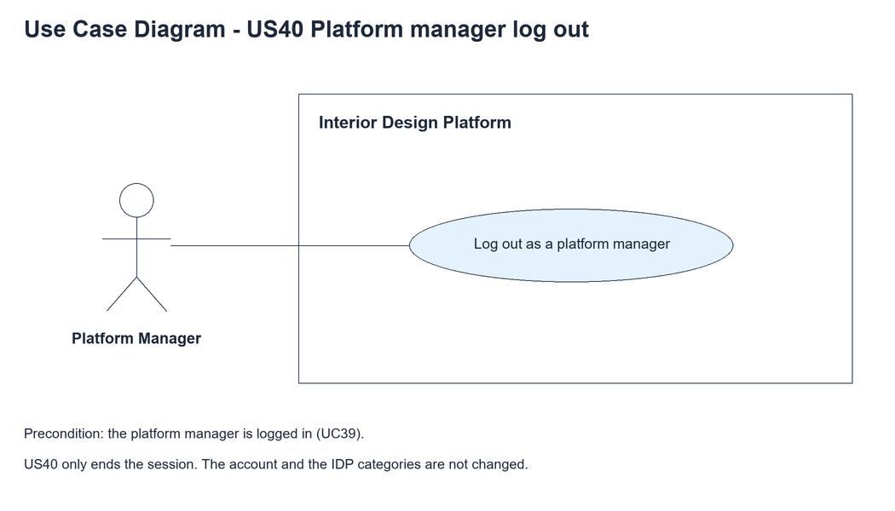
Figure 1: Use case diagram for US40 Platform manager log out

3. Use case description
Use case | UC40 Platform manager log out
Actor | Platform Manager
Brief description | The Platform Manager logs out so other people can't use their account on this browser.
User story | US40: As a platform manager, I want to log out so that other people cannot use my account.
Preconditions | The Platform Manager is logged in (UC39).
Trigger | The Platform Manager clicks "Log out" in the header of any manager page.
Basic flow | 1. The Platform Manager clicks "Log out".  2. The system checks that there is a logged-in session.  3. The system ends the session and clears all session data.  4. The system shows the manager login page with "You have logged out successfully".
Alternative flows | 2a. There is no logged-in session (it already ended): the system clears anything left in the session and shows the manager login page with "Your session has already ended".
Postconditions | The session is cleared. Manager pages need a new login.  The user account and the IDP categories are not changed.

4. Wireframes
The wireframes were drawn in draw.io. They are low-fidelity: they show the layout and the flow, not the final colours. The orange numbers match the notes under each screen.

4a - Logout button
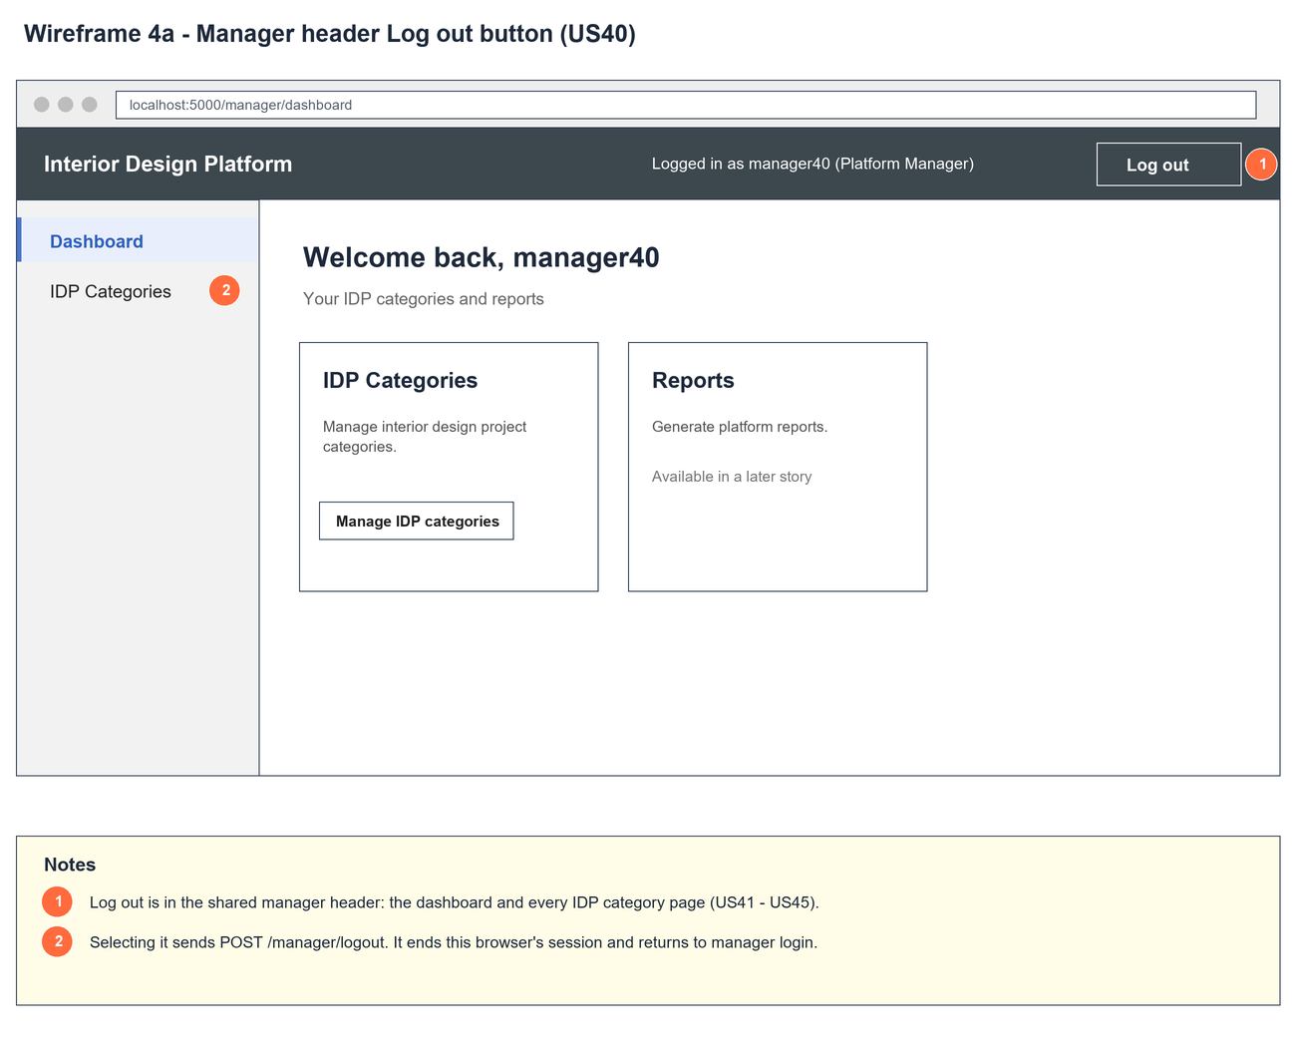
Figure 2: Wireframe 4a - Logout button (US40)

4b - Logged out
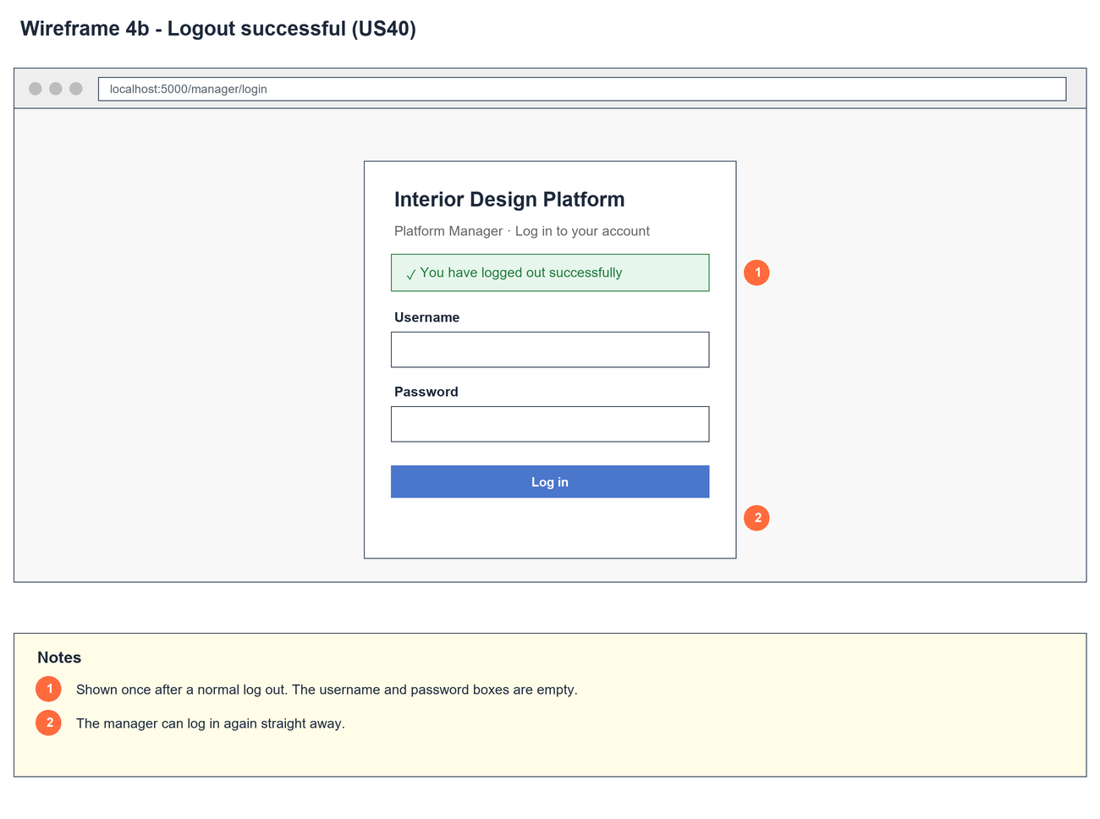
Figure 3: Wireframe 4b - Logged out (US40)

4c - Session already ended
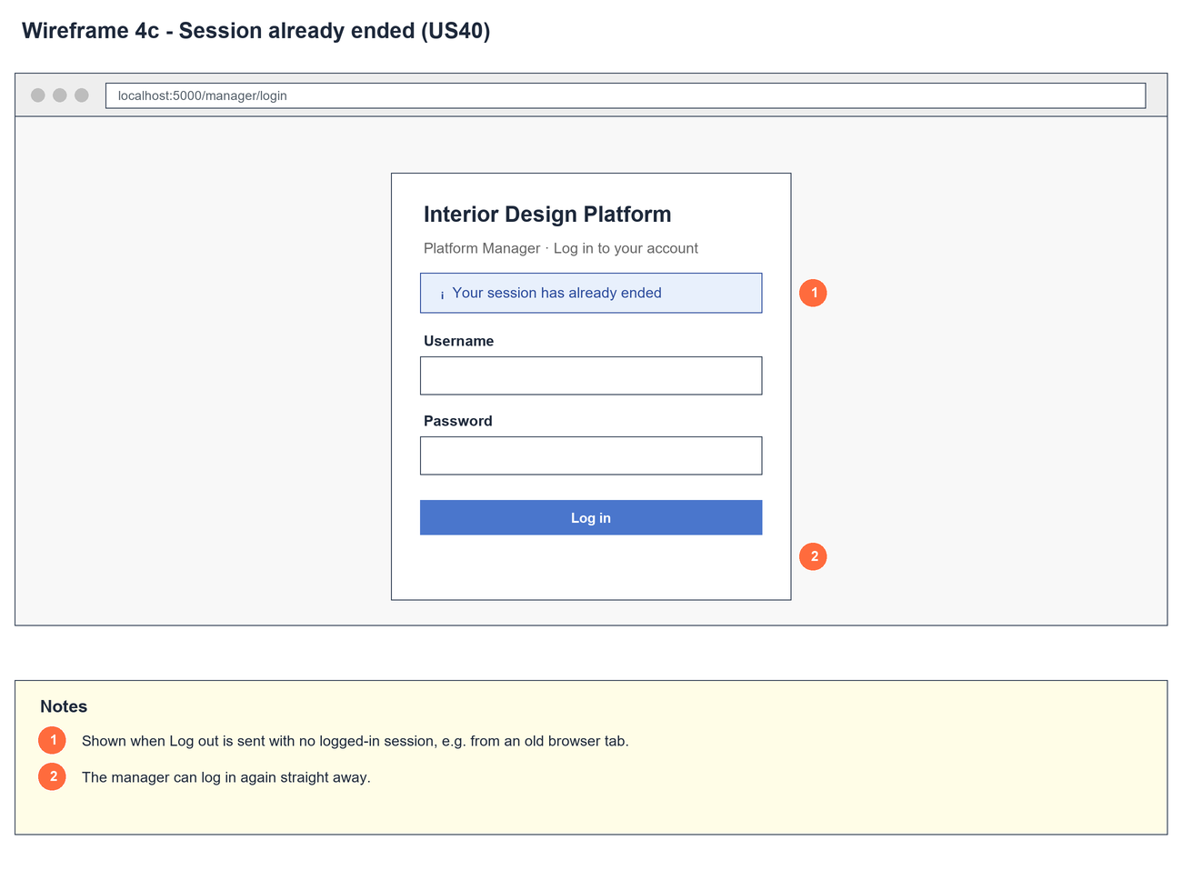
Figure 4: Wireframe 4c - Session already ended (US40)

4d - Protected page blocked
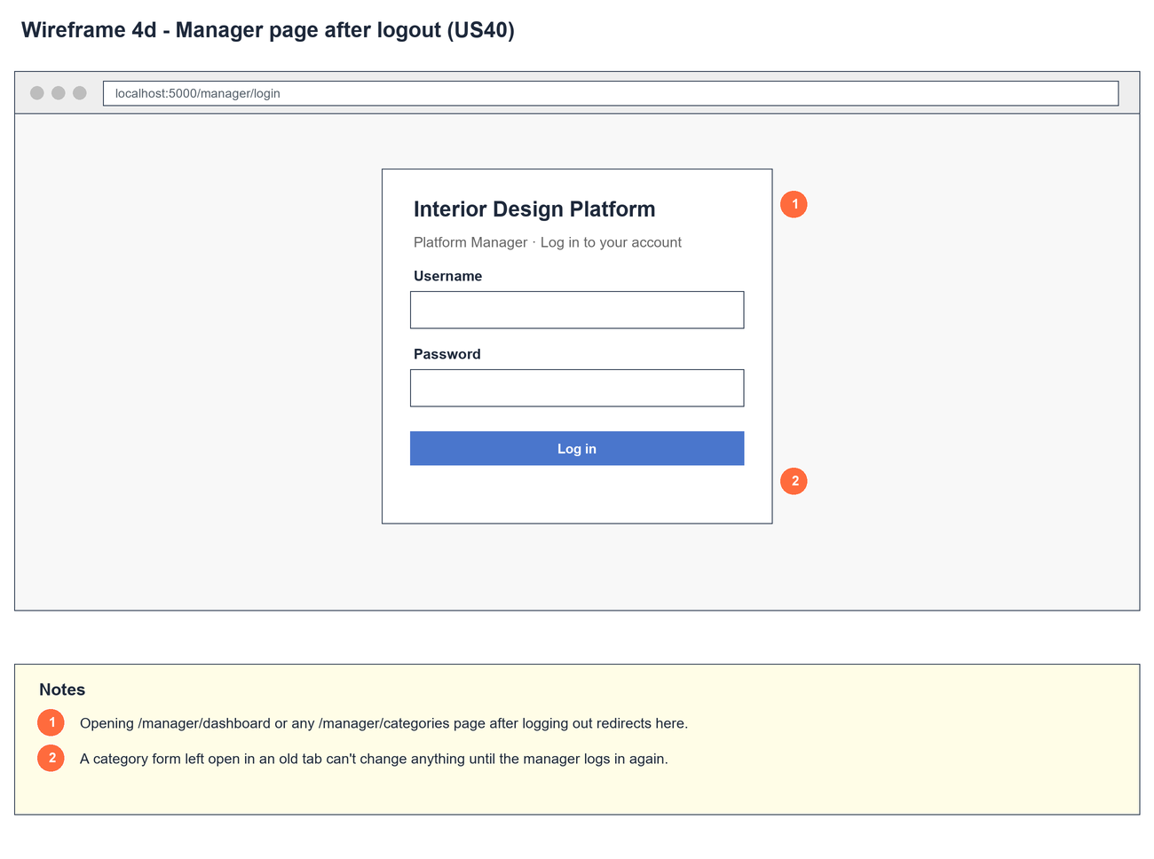
Figure 5: Wireframe 4d - Protected page blocked (US40)

5. B-C-E class diagram
The solid line means the boundary calls the controller. The dashed lines mean the controller uses the other classes. Only the operations needed for this use case are shown, with the same names as the code.
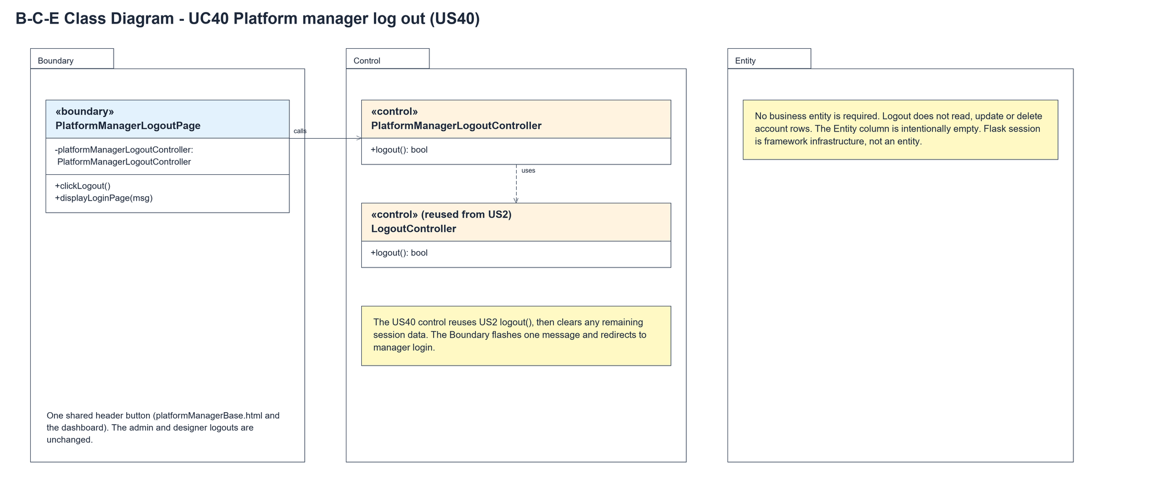
Figure 6: B-C-E class diagram for US40 Platform manager log out
Layer | Class | What it does
Boundary | PlatformManagerLogoutPage | The "Log out" button in the manager header. clickLogout() asks the controller to log out, and displayLoginPage(msg) flashes the message and redirects to /manager/login.
Control | PlatformManagerLogoutController | Controller for UC40. logout() calls the US2 LogoutController, then clears the whole session. Returns true if a session was ended.
Control | LogoutController (from US2) | logout() ends the session if a userId is in it, and returns true or false.
Entity | (none) | No entity is needed - logging out doesn't read or change any account or IDP category data. The Flask session is framework infrastructure.

6. Sequence diagram
The sequence diagram follows UC40. The page asks PlatformManagerLogoutController to log out, and it calls the US2 LogoutController. The first alt checks if a userId is in the session: if so the session is cleared and True comes back, otherwise False. The controller then clears anything left. The second alt picks the message that the page flashes before redirecting to the manager login page.
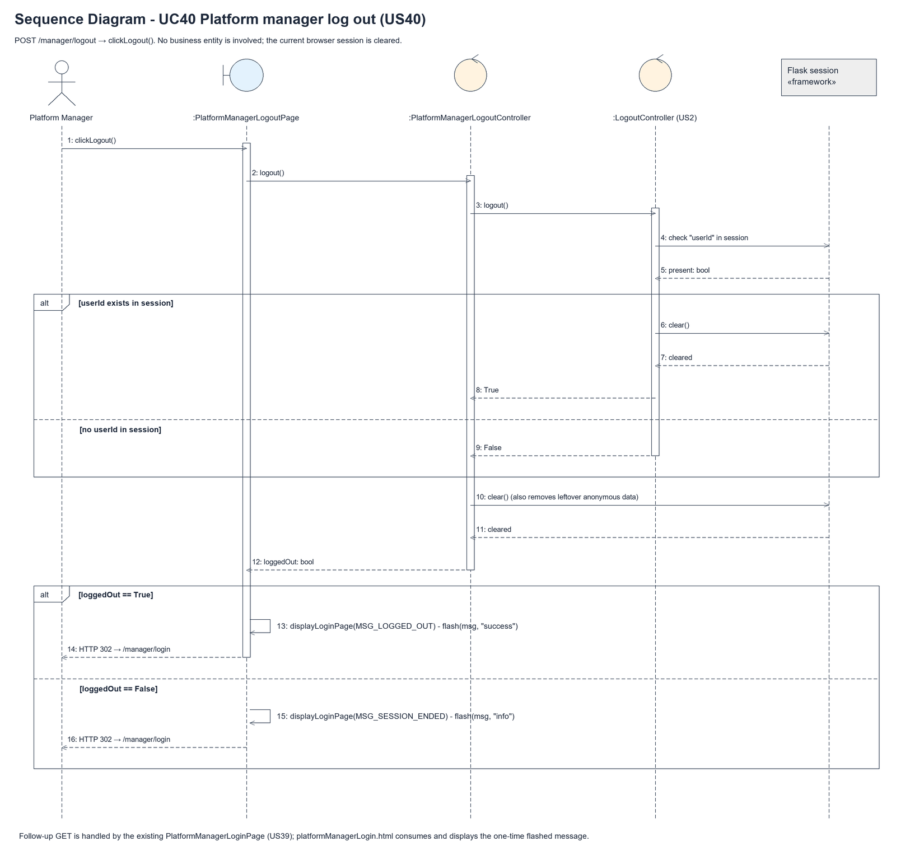
Figure 7: Sequence diagram for UC40 Platform manager log out

7. Test cases
Test data used below (same as database/seedData.py and the test files): user profiles User Admin (id 1), Interior Designer (id 2), Customer (id 3) and Platform Manager (id 4), all Active. User accounts admin01 / Admin@123 (User Admin) and cust001 / Cust@123 (Customer). The manager account manager40 / Manager@123 (Daniel Tan, Platform Manager profile) is made first with UC8.

7a. System test cases (black box)
Equivalence partitioning and boundary value analysis were used to pick the test data. Fill in "Actual result" and "Pass/Fail" after running each test.
Test ID | Scenario | Prerequisites | Test steps | Test data | Expected result | Actual result | Pass / Fail
TC40.1 | Log out | Logged in as manager40. | 1. Click "Log out" in the header | - | Manager login page with "You have logged out successfully". The username box is empty.
TC40.2 | Log out button on every manager page | Logged in as manager40. | 1. Open the dashboard and the IDP Categories, create, view and update pages | - | Every page has a "Log out" button.
TC40.3 | Pages are blocked after logging out | TC40.1 done. | 1. Open /manager/dashboard  2. Open /manager/categories | - | Both send me to the manager login page.
TC40.4 | Session already ended | Not logged in. | 1. Send a log out request (e.g. from an old tab) | - | Manager login page with "Your session has already ended".
TC40.5 | Message is only shown once | TC40.1 done. | 1. Refresh the login page | - | The "logged out" message is gone.
TC40.6 | Log in again | TC40.1 done. | 1. Log in as manager40 | manager40 / Manager@123 | Manager dashboard. The account is still Active.
TC40.7 | GET can't log out | Logged in as manager40. | 1. Type /manager/logout in the address bar | GET request | HTTP 405 Method Not Allowed. Still logged in.

7b. Unit test cases (for TDD)
These are written before the code (test-driven development) and run with pytest. They cover normal inputs, abnormal inputs and boundary values. Each one matches a test function in tests/test_us40_platformManagerLogout.py (UT40.n = test_ut40_n_...).
Test ID | Class and method | Input / setup | Expected output | Type | Pass / Fail
UT40.1 | PlatformManagerLogoutController.logout() | Session has userId | Returns true. userId removed | Normal | Pass
UT40.2 | PlatformManagerLogoutController.logout() | Empty session | Returns false | Abnormal | Pass
UT40.3 | PlatformManagerLogoutController.logout() | Called twice | True, then false | Boundary | Pass
UT40.4 | PlatformManagerLogoutController.logout() | No userId but other data left | Returns false. Session is empty | Abnormal | Pass
UT40.5 | Manager dashboard header | Logged in as manager40 | Has the "Log out" button posting to /manager/logout | Normal | Pass
UT40.6 | Manager page header (platformManagerBase.html) | Open /manager/categories | Has the "Log out" button | Normal | Pass
UT40.7 | PlatformManagerLogoutPage.clickLogout() | POST /manager/logout | Redirects to /manager/login | Normal | Pass
UT40.8 | PlatformManagerLogoutPage.displayLoginPage() | POST and follow the redirect | "You have logged out successfully" and the login form | Normal | Pass
UT40.9 | PlatformManagerLogoutPage.clickLogout() | POST /manager/logout | No userId, profileId or username in the session | Normal | Pass
UT40.10 | PlatformManagerLogoutPage.displayLoginPage() | POST with no session | "Your session has already ended" | Abnormal | Pass
UT40.11 | /manager/logout route | GET /manager/logout | HTTP 405. Still logged in | Abnormal | Pass
UT40.12 | Manager dashboard after logging out | GET /manager/dashboard | Redirects to /manager/login | Normal | Pass
UT40.13 | Category pages after logging out | GET /manager/categories and /manager/categories/create | Both redirect to /manager/login | Normal | Pass
UT40.14 | PlatformManagerLogoutPage.clickLogout() | Logged in, then log out | Account still Active | Normal | Pass
UT40.15 | Log in again | Log out, then log in as manager40 | Redirects to /manager/dashboard | Normal | Pass
UT40.16 | PlatformManagerLogoutPage.displayLoginPage() | Log out, then open the login page again | Message shown once only | Boundary | Pass
UT40.17 | LogoutPage (US2, /logout) | admin01 logs out | US2 login page with "You have logged out successfully", not the manager one | Normal | Pass
UT40.18 | Manager page header (platformManagerBase.html) | manager40 opens /manager/categories | "Logged in as manager40 (Platform Manager)" | Normal | Pass

